PCT | Question 2: No of Children with an ASD Diagnosis | Question 3b) ASD Pathway
Knowsley | 335 children as at November 2011 (2008 to date - latest data available) | 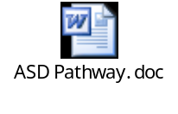
Halton | 22 children Diagnosed ,12 in system awaiting diagnosis (data from Jan 2012 to present day) | 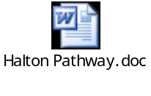
St Helens | 66 July 2011-2012 (latest data) | 
Sefton | Not available | Educational psychologists, ASD Nurses, Speech and Language Therapist, ASD Specialist Teacher, Community Paediatrician
Liverpool | National prevalence is 1 per cent for diagnosis. Currently Liverpool ASD assessment services diagnose annually 208 across age ranges. |   Current ASD assessment process in draft form as currently being tested. Multi agency, multi disciplinary integrated ASD pathway in existence since 03/04 based on best practice evidence based model.

