FOI & Data Protection | 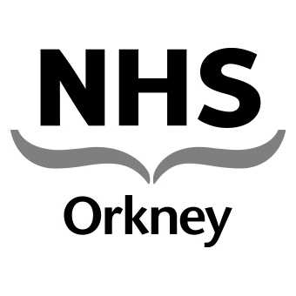  Balfour Hospital  New Scapa Road  Kirkwall  Orkney KW15 1BH  www.ohb.scot.nhs.uk
Sarah McCulloch | Date: 6th July 2012  Tel: 01856 888 220  Fax: 01856 888 211  Enquiries to: Mrs Kirsty Sutherland  Email: ork-hb.foirequests@nhs.net
Dear Ms McCulloch,

RE: FOI Request for Information – request 2012 / 160 re: Autistic spectrum disorder

Your Query | Date of Request | 25th June 2012
I've been given this email for Freedom of Information for your PCT. Please could I get an FOI from your PCT for the following:
- How many adults you have with a diagnosis of autistic spectrum disorder (any, although if there are separate statistics for Asperger's, HFA, LFA, they would be appreciated) in your area;
- How many children;
- What diagnostic services are available to a) adults and b) children;
- What agencies or teams you have that work with autistic people, provide support/services, strategise, etc.
- An email address/website for each of these agencies or teams where possible.
- What the typical process should be for an adult in your area first asking their GP for an assessment for autistic spectrum disorder to receiving a diagnosis/support

Response
This response is provided in accordance with Freedom of Information (Scotland) Act 2002
Note: NHS Orkney is not a ‘PCT’ but is a small remote and rural health board within Scotland.

- NHS Orkney does not hold a register of the number of people in Orkney with autism and therefore, I must advise that in terms of Section 17 of the Freedom of Information (Scotland) Act 2002 the information sought is not held.

- The information requested is reported to and publicly available from the General Register Office for Scotland: http://www.gro-scotland.gov.uk/statistics/index.html (go to Council Area profiles and select Orkney). Exemption applied under Section 25 of FOISA - information is otherwise accessible.

- NHS Orkney provides
- assessment within the general psychiatry service for adults and
- for children the evidence based tools used are the CHAT checklists, the Tony Attwood Rating Scale and the Communication Skills Profile. Much greater emphasis however is put on collating information from observation over time within a number of different settings

- NHS Orkney does not have any specialist services for adults with aspergers syndrome.
NHS Orkney and Orkney Islands Council run a joint multidisciplinary education programme involving teams from Educational Psychology, Speech and Language Therapy teaching staff and sometimes occupational therapy, physiotherapy and paediatricians. This programme is administered by Orkney Islands Council and is delivered to individual children families in their own homes once a child has been diagnosed.

- http://www.orkney.gov.uk/Service-Directory/A/Autistic-Spectrum-Disorder.htm

- Within NHS Orkney the “typical process” for an adult patient in the scenario given would be as follows:-
  - The patient would be referred to NHS Orkney’s Community Mental Health team (CMHT)
  - If they met the criteria for assessment the patient would be seen by the CMHT
  - If it was clearly determined at the assessment that the patient either did or did not have a diagnosis, this would be stated to them at the conclusion of the assessment.
  - If the diagnosis was unclear the patient would be referred outside the NHS Orkney Board area for further assessment.
  - Any necessary support would be delivered according to an assessment of needs.

Note: The Information Services Division, ISD Practice Team Information (PTI) can provide estimates, at a national level, of patients consulting within General Practice for ASD, but this is likely to underestimate actual numbers of people with ASD. ASD may be seen as a ‘social’ condition and so people with ASD may not seek medical treatment/advice on a regular basis.

Some data on autism is available on the Scottish Public Health Observatory pages, here: http://www.scotpho.org.uk/home/Healthwell-beinganddisease/MentalHealth/Data/mental_autism.asp

There is also a 2008 SG publication which estimates prevalence of autism, available here: http://www.scotland.gov.uk/Publications/2008/03/27085247/12

I hope this helps with your request.

Under section 20 (1) of the Act, if you are dissatisfied with the way NHS Orkney has dealt with your request, you have a right to ask for a review of our actions and decisions in relation to your request, and you have a right to appeal to the Scottish Information Commissioner.

A request for review should be made within 40 working days of receipt of this letter and NHS Orkney will reply within 20 working days of receipt. Review requests should be sent in writing to Dr Louise Wilson, Director of Public Health, NHS Orkney, Garden House, New Scapa Road, Kirkwall, Orkney KW15 1BQ or by e-mail via ork-hb.foirequests@nhs.net.

Requests for appeal should be made in writing to: Scottish Information Commissioner, Kinburn Castle, Doubledykes Road, St Andrews, Fife, KY16 9DS. Telephone: 01334 464610, Fax: 01334 464611, e.mail: enquiries@itspublicknowledge.info.

FOI responses (subject to the removal of personal information) may appear on NHS Orkney’s Freedom of Information website at: http://www.ohb.scot.nhs.uk/article.asp?page=13&parent=5.

Yours sincerely,
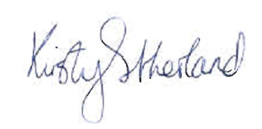
Freedom of Information Officer
NHS Orkney

